Module 2 problem set:
1, single choice, level: basic
(1) The figure shows three paths connecting points a and b. A single force does the indicated work on a particle moving along each path in the indicated direction. On the basis of this information, is force conservative?
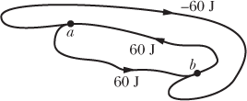
A, Yes
B, No
Ppt 9, section 8-1

(2) A particle is to move along an x axis from x = 0 to x1 while a conservative force, directed along the x axis, acts on the particle. The figure shows three situations in which the x component of that force varies with x. The force has the same maximum magnitude F1 in all three situations. Rank the situations according to the change in the associated potential energy during the particle’s motion, most positive first.
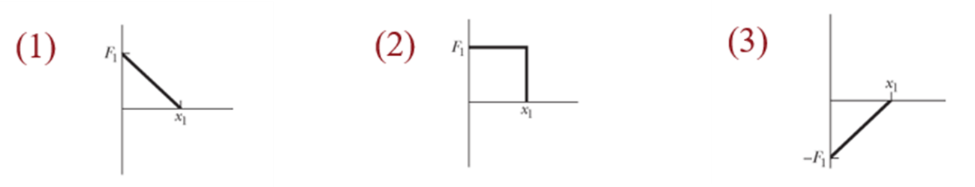
A, 1>2>3
B, 3>2>1
C, 1>3>2
D, 3>1>2
Ppt 9, section 8-1

(3) The figure shows four situations—one in which an initially stationary block is dropped and three in which the block is allowed to slide down frictionless ramps. Rank the situations according to the kinetic energy of the block at point B, greatest first.
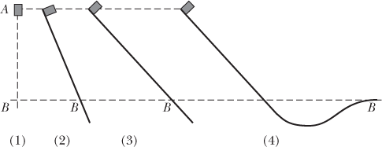
A, 4>3>2>1
B, 1>2>3>4
C, 1=2=3=4
D, 4=3=2>1
Ppt 9, section 8-2

(4) A particle is to be placed, in turn, outside four objects, each of mass m: (1) a large uniform solid sphere, (2) a large uniform spherical shell, (3) a small uniform solid sphere, and (4) a small uniform shell. In each situation, the distance between the particle and the center of the object is d. Rank the objects according to the magnitude of the gravitational force they exert on the particle, greatest first.
A, 1=2=3=4
B, 1=2>3=4
C, 1>2>3>4
D, 1>2=3>4
Ppt 11, section 13-1

(5) You move a ball of mass m away from a sphere of mass M. (a) Does the gravitational potential energy of the system of ball and sphere increase or decrease? (b) Is positive work or negative work done by the gravitational force between the ball and the sphere?
A, increase; positive
B, increase; negative
C, decrease; positive
D, decrease; negative
Ppt 11, section 13-5

(6) Satellite 1 is in a certain circular orbit around a planet, while satellite 2 is in a larger circular orbit. Which satellite has (a) the longer period and (b) the greater speed?
A, 1; 1
B, 1; 2
C, 2; 1
D, 2; 2
Ppt 11, section 13-6

2, single choice, level – intermediate
(1) The periods of a spring oscillator (under horizontal SHM) and a pendulum are T₁ and T₂, respectively. If they are placed in the moon with decreased gravitational acceleration, the periods become T₁’ and T₂’. Then
(A) T₁’> T₁ and T₂’> T₂ (B) T₁’< T₁ and T₂’< T₂
(C) T₁’= T₁ and T₂’= T₂ (D) T₁’= T₁ and T₂’> T₂
Ppt 12

(2) A sinusoidal wave is traveling along the negative direction of x axis, with angular frequency of ω and traveling velocity of u. If the waveform at t=T/4 is as the figure below, then the wave can be expressed as:
(A)
(B)
(C)
(D)
Ppt 12

(3) When an aerospace shuttle (mass m) returns to the Earth with engine off, in which the distance between itself to the Earth center changes from R₁ to R₂, the increased kinetic energy of the shuttle will be: (M as Earth mass, G as the gravitational constant)
(A) (B) (C)
(D) (E)
Ppt 11

(4) A spring with spring constant k was placed on an inclined surface with inclination angle α, in which one end was fixed on Baffle A, and the other end was connected to object B with mass m. Point O is the balance position with no connected object B, and point a is the equilibrium position with connection of object B. Now move object B from point a along the slope to point b (as shown in the picture). Assume that the distances between point a and point O, and point a and point b are x₁ and x₂, respectively, then during this process, the potential energy of the system composed of spring, object B and the earth increases as
(A)
(B)
(C)
(D)
Ppt 9

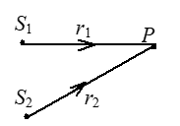
(5) Two waves are with initial phases φ₁ and φ₂, starting from points S₁ and S₂, respectively. The wavelength is λ for both. To make an construction interference, we should have:
(A) (B)
(C)
(D)
Ppt 13

(6) A satellite moves around the Earth in an ellipse shape, with the largest and the smallest distance as R_{A} and R_{B}. What is the relationship between angular momentum and kinetic energy at these two points?
(A) L_{B} > L_{A}，E_{KA} > E_{KB} (B) L_{B} > L_{A}，E_{KA} = E_{KB}
(C) L_{B} = L_{A}，E_{KA} = E_{KB} (D) L_{B} < L_{A}，E_{KA} = E_{KB}
(E) L_{B} = L_{A}，E_{KA} < E_{KB}
Ppt 11

3, Q&A, level: advanced
(1) In Figure, a block of mass m = 3.20 kg slides from rest a distance d down a frictionless incline at angle θ = 30.0° where it runs into a spring of spring constant 431 N/m. When the block momentarily stops, it has compressed the spring by 21.0 cm. What are (a) distance d and (b) the distance between the point of the first block–spring contact and the point where the block’s speed is greatest?
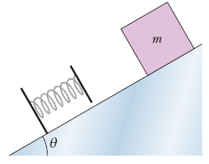
Answer: 0.396m; 3.64cm
ppt 9

(2) In Figure, a 3.5 kg block is accelerated from rest by a compressed spring of spring constant 640 N/m. The block leaves the spring at the spring’s relaxed length and then travels over a horizontal floor with a coefficient of kinetic friction 𝜇_{k} = 0.25. The frictional force stops the block in distance D = 7.8 m. What are (a) the increase in the thermal energy of the block–floor system, (b) the maximum kinetic energy of the block, and (c) the original compression distance of the spring?
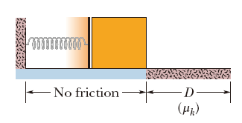
Answer: 67J; 67J; 0.46m
ppt 9

(3) In Figure, what magnitude of (constant) force F → applied horizontally at the axle of the wheel is necessary to raise the wheel over a step obstacle of height h = 3.00 cm? The wheel’s radius is r = 6.00 cm, and its mass is m = 0.800 kg.
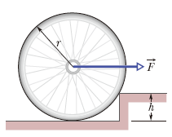
Answer: 13.6N
ppt 9

(4) In Figure, a uniform plank, with a length L of 6.10 m and a weight of 445 N, rests on the ground and against a frictionless roller at the top of a wall of height h = 3.05 m. The plank remains in equilibrium for any value of θ ≥ 70° but slips if θ < 70°. Find the coefficient of static friction between the plank and the ground.
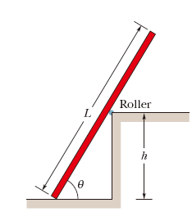
Answer: 0.34
ppt 3

(5) Several planets (Jupiter, Saturn, Uranus) are encircled by rings, perhaps composed of material that failed to form a satellite. In addition, many galaxies contain ring-like structures. Consider a homogeneous thin ring of mass M and outer radius R. (a) What gravitational attraction does it exert on a particle of mass m located on the ring’s central axis a distance x from the ring center? (b) Suppose the particle falls from rest as a result of the attraction of the ring of matter. What is the speed with which it passes through the center of the ring?
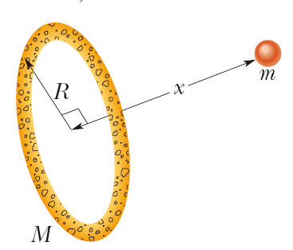
Answer: GMmx(x²+R²)^{-3/2}; sqrt(2GM(1/R-1/sqrt(x²+R²)))
ppt 11

(6) A uniform beam is 5.0 m long and has a mass of 53 kg. In the figure below, the beam is supported in a horizontal position by a hinge and a cable, with angle θ = 60°. In unit-vector notation, what is the force on the beam from the hinge?
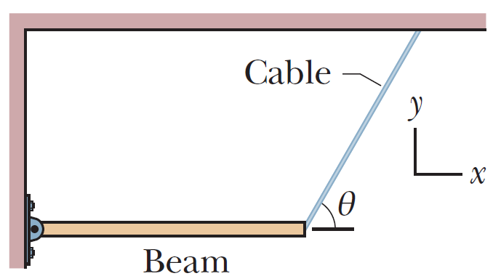
Answer: 299.9N
Ppt 9

4, Q&A, level: challenging
(1) To alleviate the traffic congestion between two cities such as Beijing and Guangzhou, engineers have proposed building a rail tunnel along a chord line connecting the cities (Fig. below). A train, unpropelled by any engine and starting from rest, would fall through the first half of the tunnel and then move up the second half. Assuming Earth is a uniform sphere and ignoring air drag and friction, find the city-to-city travel time, expressed by G, the Earth mass M and radius R. (Assume the Earth is with uniform density)
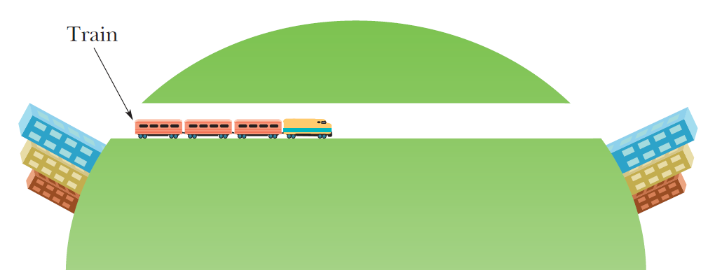
Ppt 9&11

(2) Derive tidal force equation for a small object u on the moon m around the planet M: (See figure below for the meaning of symbols)
And the Roche limit in which the u cannot stay on the moon’s surface:
Ppt 11
